Characters Introduced Through Film Techniques
Text  CHARACTER | Identify  CAMERA SHOT & ANGLE | Identify  SOUND | Identify  LIGHTING | Explain  EXPLANATION
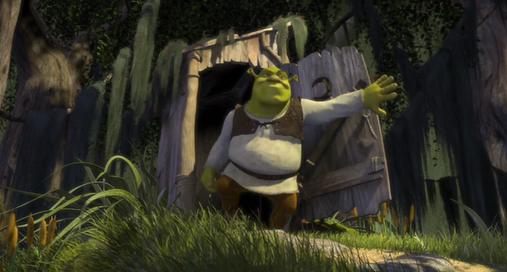  1:25 | Low angle full shot | Non-diegetic soundtrack – “All Star” by Smash Mouth plays when Shrek exits the toilet | Neutral ‘sunlight’ that lights the set and character equally | A low angle full shot is used to introduce Shrek as the stereotypical “terrifying ogre” as is traditional in fairytales. This convention is subverted, however, with the soundtrack which juxtaposes the visual characterisation. The lighting suggests that Shrek is in a comfortable environment and is ‘at one’ with the current setting due to the equal intensity of lighting on him and setting framed in this shot.
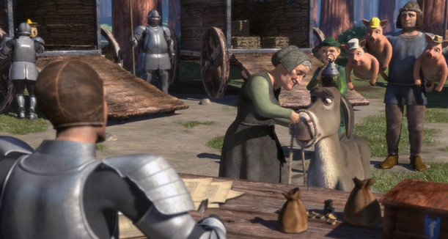
5:50
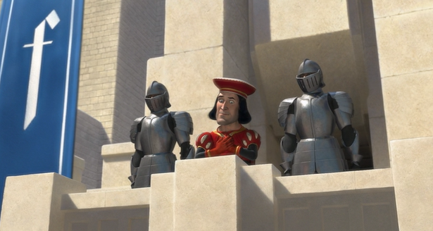
21:56
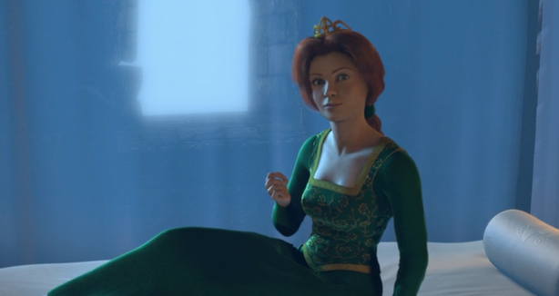
33:51

